

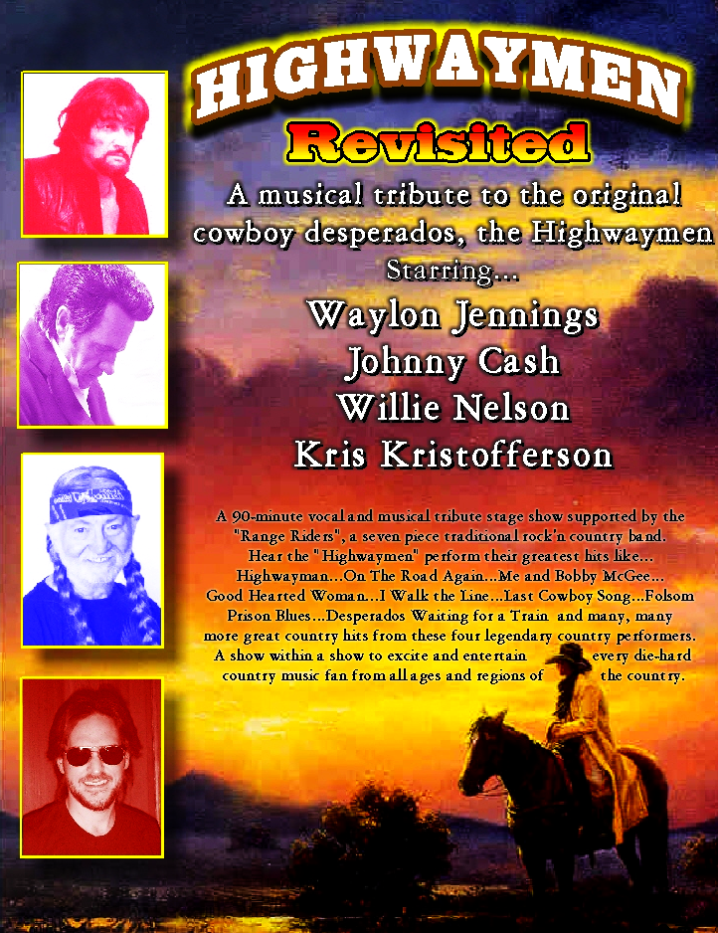

COUNTRY TRIBUTE SHOW AVAILABLE NOW !
In the background you should be hearing a 3 minute musical voice sample of each tribute artist in show and not of the original artist.

CALL SILVERADO RANCH AND CONFIRM THE HIGHWAYMEN REVISITED
CR BOOKING FOR THE 2005 / 2006 ENTERTAINMENT SEASON
Casinos . Theaters . State Fairs . Rodeos . Corporate . Stadiums . Arenas . Festivals . Special Events . Conventions

