Feature Ba-Da-Bing Show!!!!!

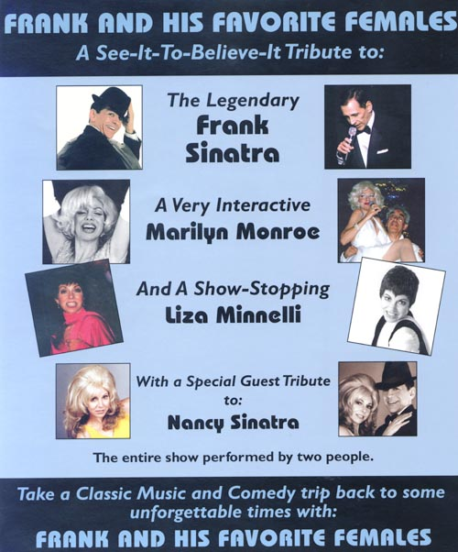

ENTIRE SHOW PERFORMED BY TWO ACTORS

MARILYN MONROE
Marilyn starts the show singing “Diamonds Are A Girl's Best Friend”. Then, Marilyn does a short welcome and monologue. Next, Marilyn finds a male audience member and seats him on stage. While running her fingers through his hair to the delight of the audience, Marilyn sings “My Heart Belongs To Daddy”.

FRANK SINATRA - 50' S
Frank enters in Vintage 50's Wardrobe and launches into a hit song medley sprinkled with crowd-pleasing jokes, The songs Include “I've Got You Under My Skin”, “Come Fly With Me”, “You Make Me Feel So Young”, “Young At Heart”, “Witchcraft”, and “Luck Be A Lady”,

NANCY SINATRA
Nancy enters in sexy mini-skirt and boots and sings “These Boots Are Made For Walking”, and “Sugartown”.

FRANK & NANCY
Frank re-enters, now changed into his 60's Tuxedo, fresh from Las Vegas. Frank and Nancy have some Father/Daughter lines together, and then sing their duet "Something Stupid", which was Number One In 1967.

FRANK SINATRA - THE 60'S & 70’S
Frank remains on stage to sing his 60's and 70's hits, Including “The Lady Is A Tramp”, “Fly Me To The Moon”, “The Summer Wind”, “The Way You Look Tonight”, “The Best Is Yet To Come”, and “My Way”.

LIZA MINELLI
Liza enters and performs a powerful medley Including “Hello Dolly”, “Maybe This Time”, “Liza With A Zit”, and of course, “Cabaret”.

FRANK & LIZA
For the show's grand finale, Frank re-enters, and he and Liza do a duet of their
mutual hit "New York, New York", ending the show on a high note ... (Literally!) ...
Sometimes to the accompaniment of an impromptu Kick Line formed by female audience members!

CONTACT: arnold@dallaswesternparties.com
www.dallaswesternparties.com Phone: 972-252-0909
4/19/2005

