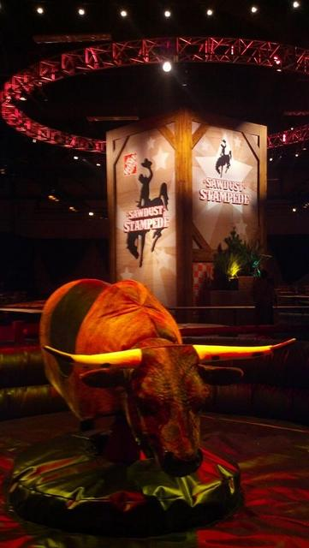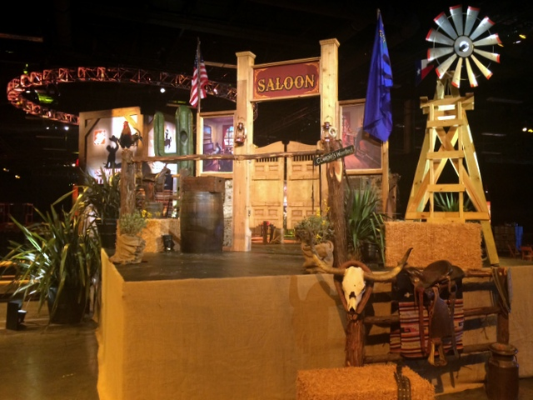
Western Prop Rental Agreement information form
Please fill in the billing and delivery spaces and fax back to: 972-514-0000
Or email to: arnold@silveradoranch.com

Any unknown or undetermined times, dates, contacts etc. please show as TBD (to be determined)

Name / type of event: |  | Number of guests:
Contact:
Customer:
Address:
City & State:
Phone:
Fax:
Cell #:
E-mail:
Web:
Delivery Date or customer pick up date:
Event rental Day/ s from:
Event hours from:
Deliver location:
Delivery address:
Delivery City & State:
Destination :
Booth size & number:
Set up time & date:
Strike time & date: Customer Return Date: Time:
Site Contact: | Contact’s cell: | Facility phone #:
Facility Contact: | Facility or event contact’s cell:
214-686-4872
Metro 972-399-4000
Toll Free 1-877-742-9872
www.silveradoranch.com

View props page for reference

Quantity Description or item page number

