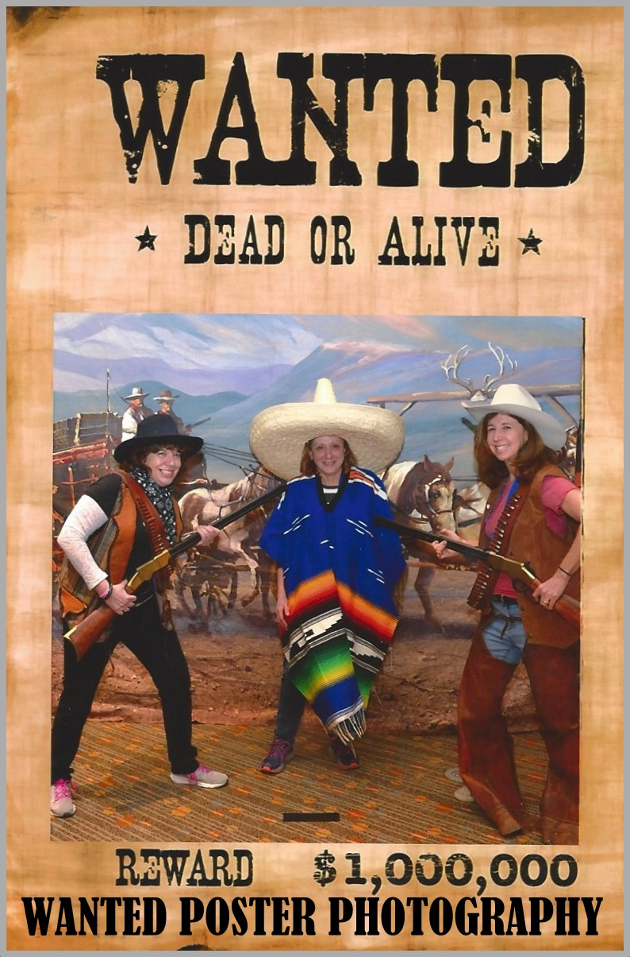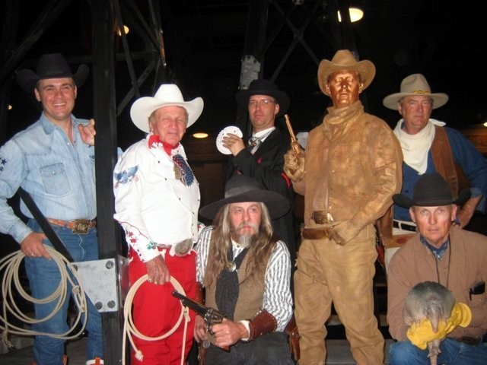
Entertainment Agreement information form
Please fill in the billing and entertainment information spaces and fax back to: 972-514-0000
Or email to: arnold@silveradoranch.com

Any unknown or undetermined times, dates, contacts etc. please show as TBD (to be determined)

Name / type of event: |  | Number of guests:
Contact:
Customer:
Address:
City & State:
Phone:
Fax:
Cell #:
E-mail:
Web:
Performance date:
Scheduled performance times or sets:
Location:
Address:
City & State & Zip :
Destination :
Booth number:
Set up time & date:
Spot time & date:
Site Contact: | Contact’s cell: | Facility phone #:
Facility Contact: | Facility or event contact’s cell:
214-686-4872
Metro 972-399-4000
Toll Free 1-877-742-9872
www.silveradoranch.com

View Entertainment page for reference

Please list any specific event details concerning set up or performers instructions

